 

Experiment No. 1.3

|  |  |
| --- | --- |
| **Student Name: Rohit Kumar** | **UID: 22MCC20172** |
| **Branch: MCA CC&DEVOPS** | **Section/Group: MCD-1/ Grp A** |
| **Semester: 3RD** | **Date of Performance: 01/09/23** |
| **Subject Name: DevOps Process Automation Lab** | **Subject Code: 22CAP-745** |

1. **Aim/Overview of the practical:**

Install and configure Apache Maven

Verify that Maven has been installed correctly on your system

Create a sample project using Maven. Create a new Maven project with the following specifications:

* Group ID: **Rohit**
* Artifact ID: **Project**
* Version: **1.0**
* Packaging: **Default**
* Java Version: **17.0.8**

Implementing a Maven repository

1. **Code for practical:** Step 1: Install java and verify its installation using java –version command.

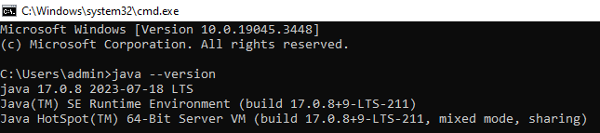

Step 2: Download and Install Maven



<https://maven.apache.org/download.cgi>

After fetching maven set Environment Variable

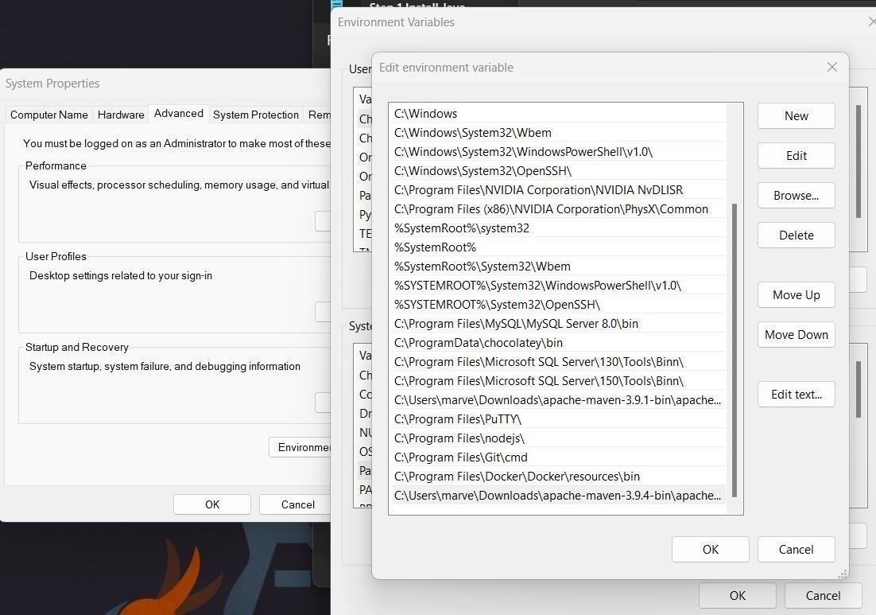

Step 3 : Verify that Maven has been installed correctly on your system mvn –version. Step 4 : run mvn archetype:generate for downloading the binary of maven.



Step 4: Create a sample project using Maven. 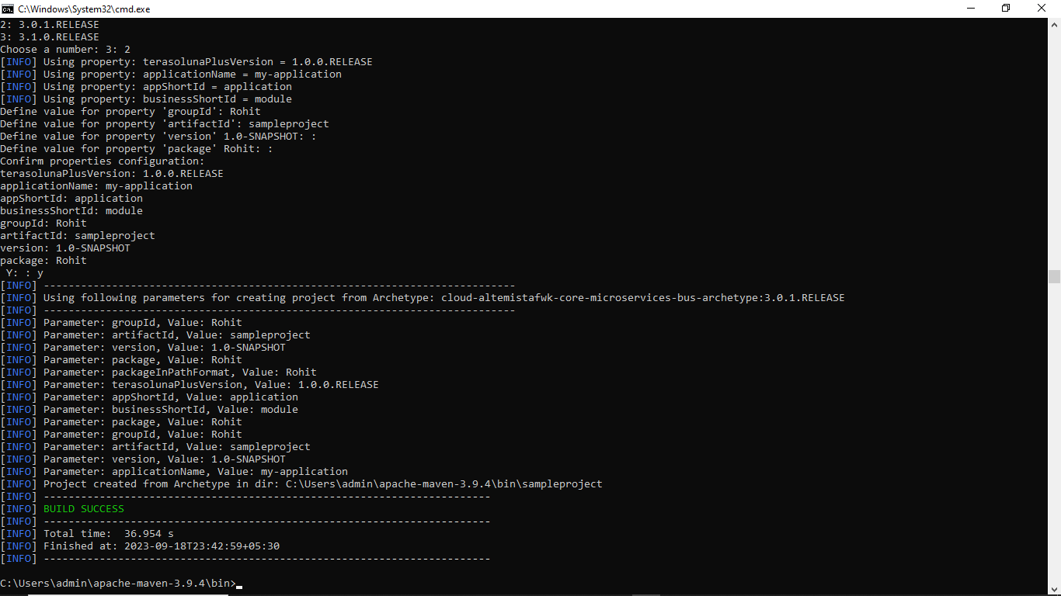

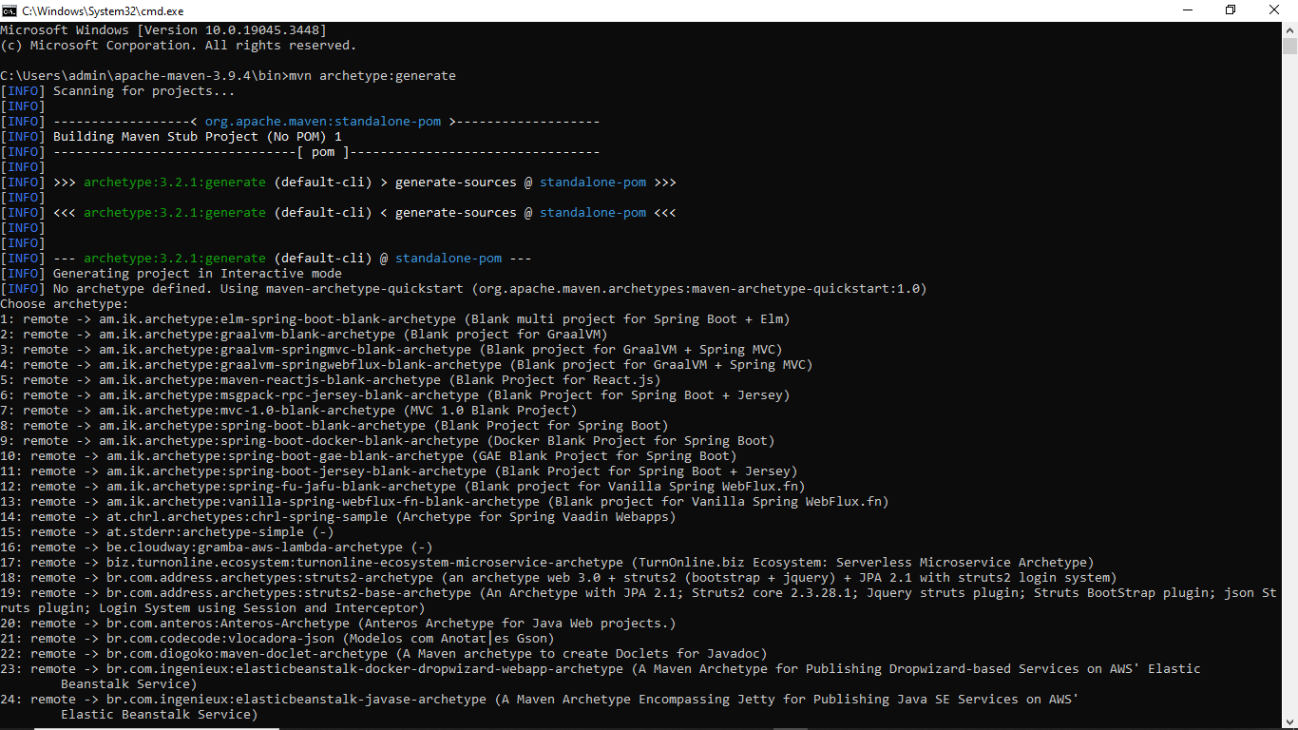



Step 5: Open POM File in Inside the folder where you run Maven archetype command.

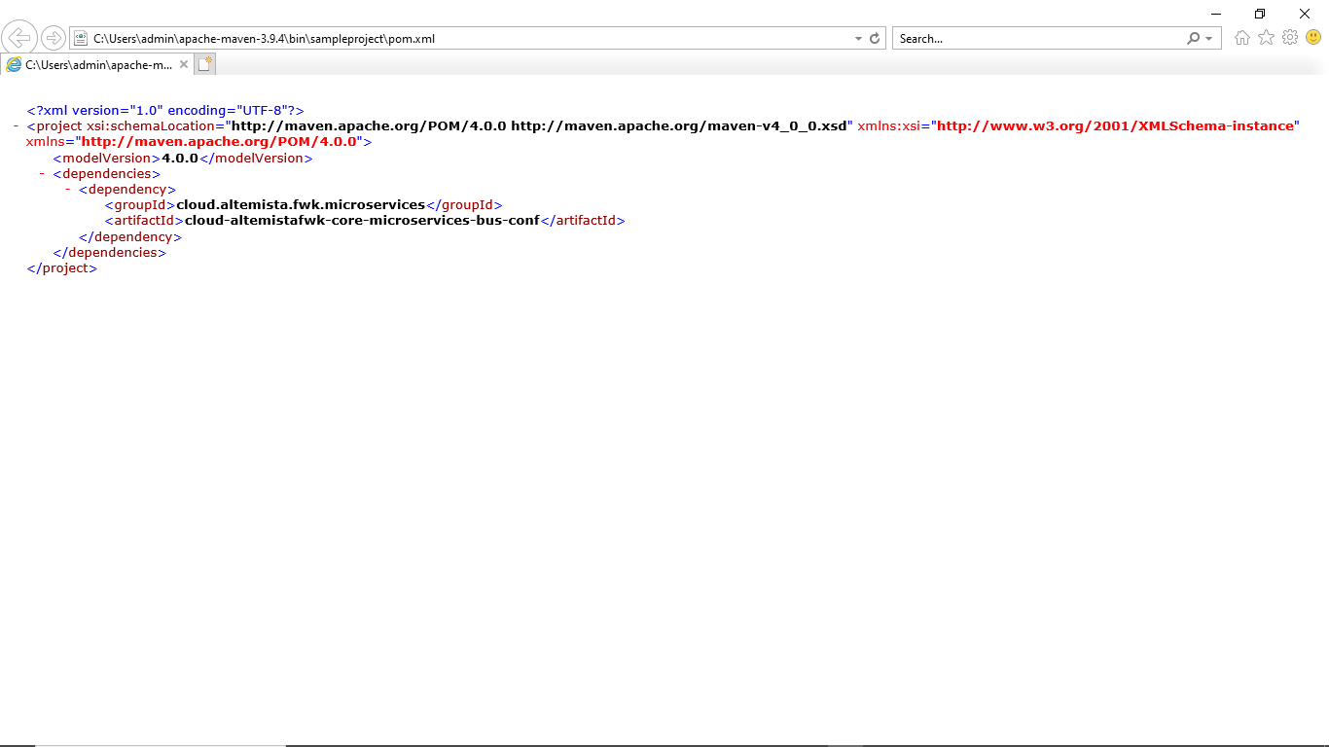

Step 6: Run mvn Clean Command for cleans the project and removes all files generated by the previous build.

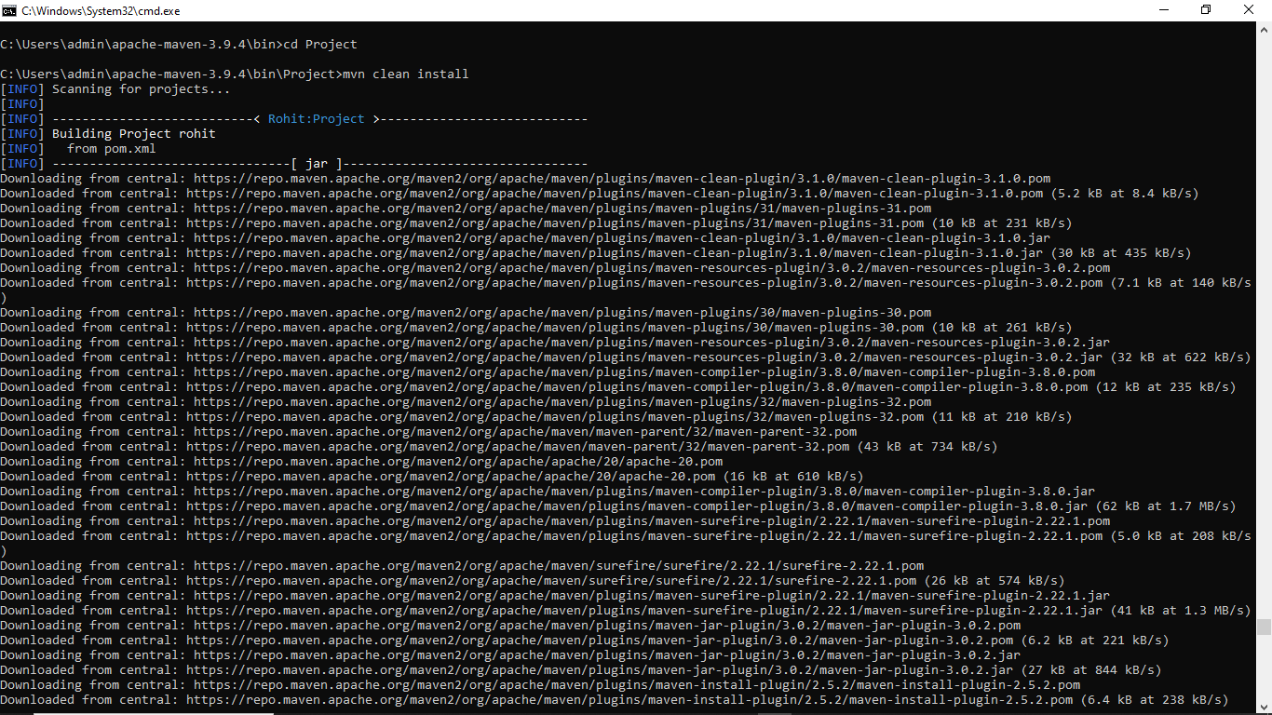

 

Step 7: Now run mvn test-compile command for compiles source code of the project.

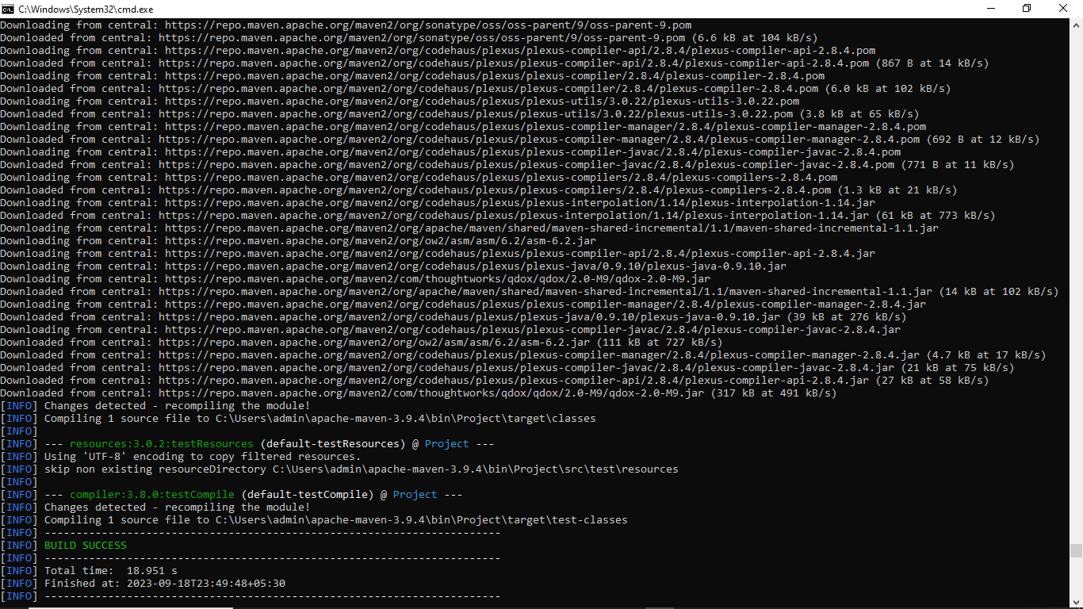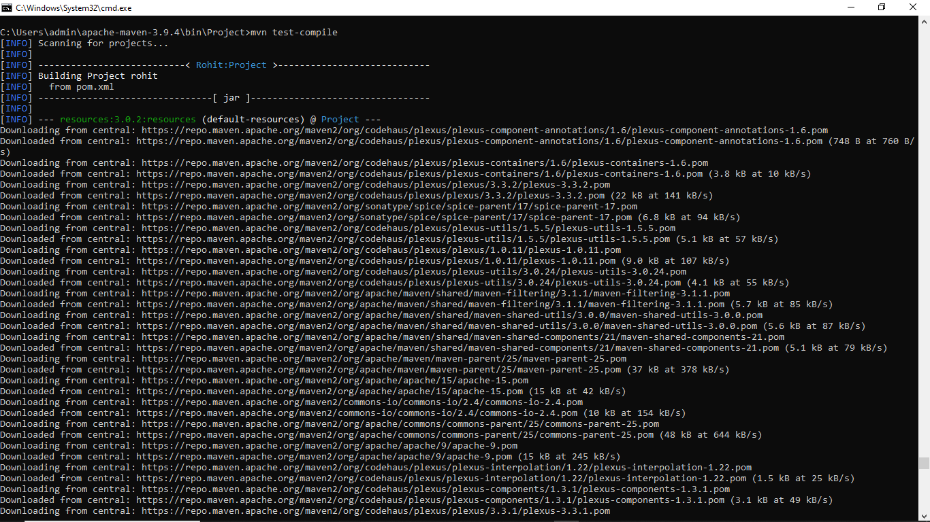



Step 8: Running Package

